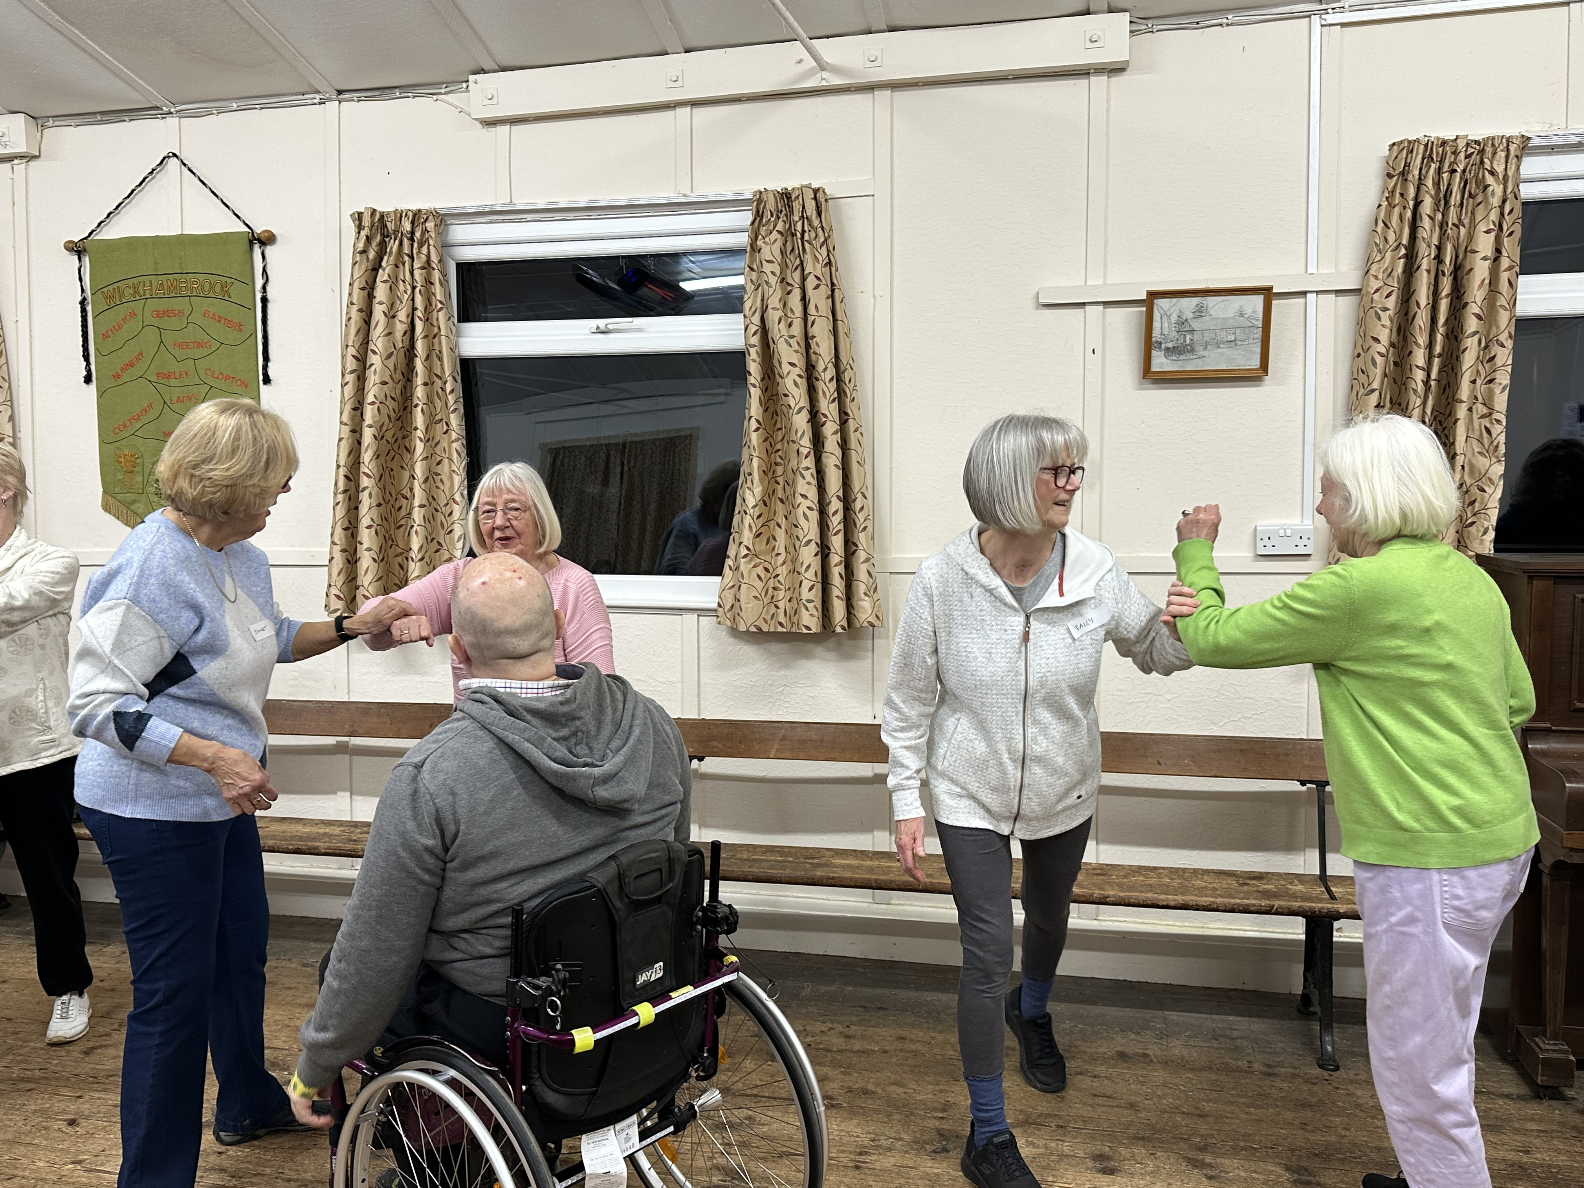
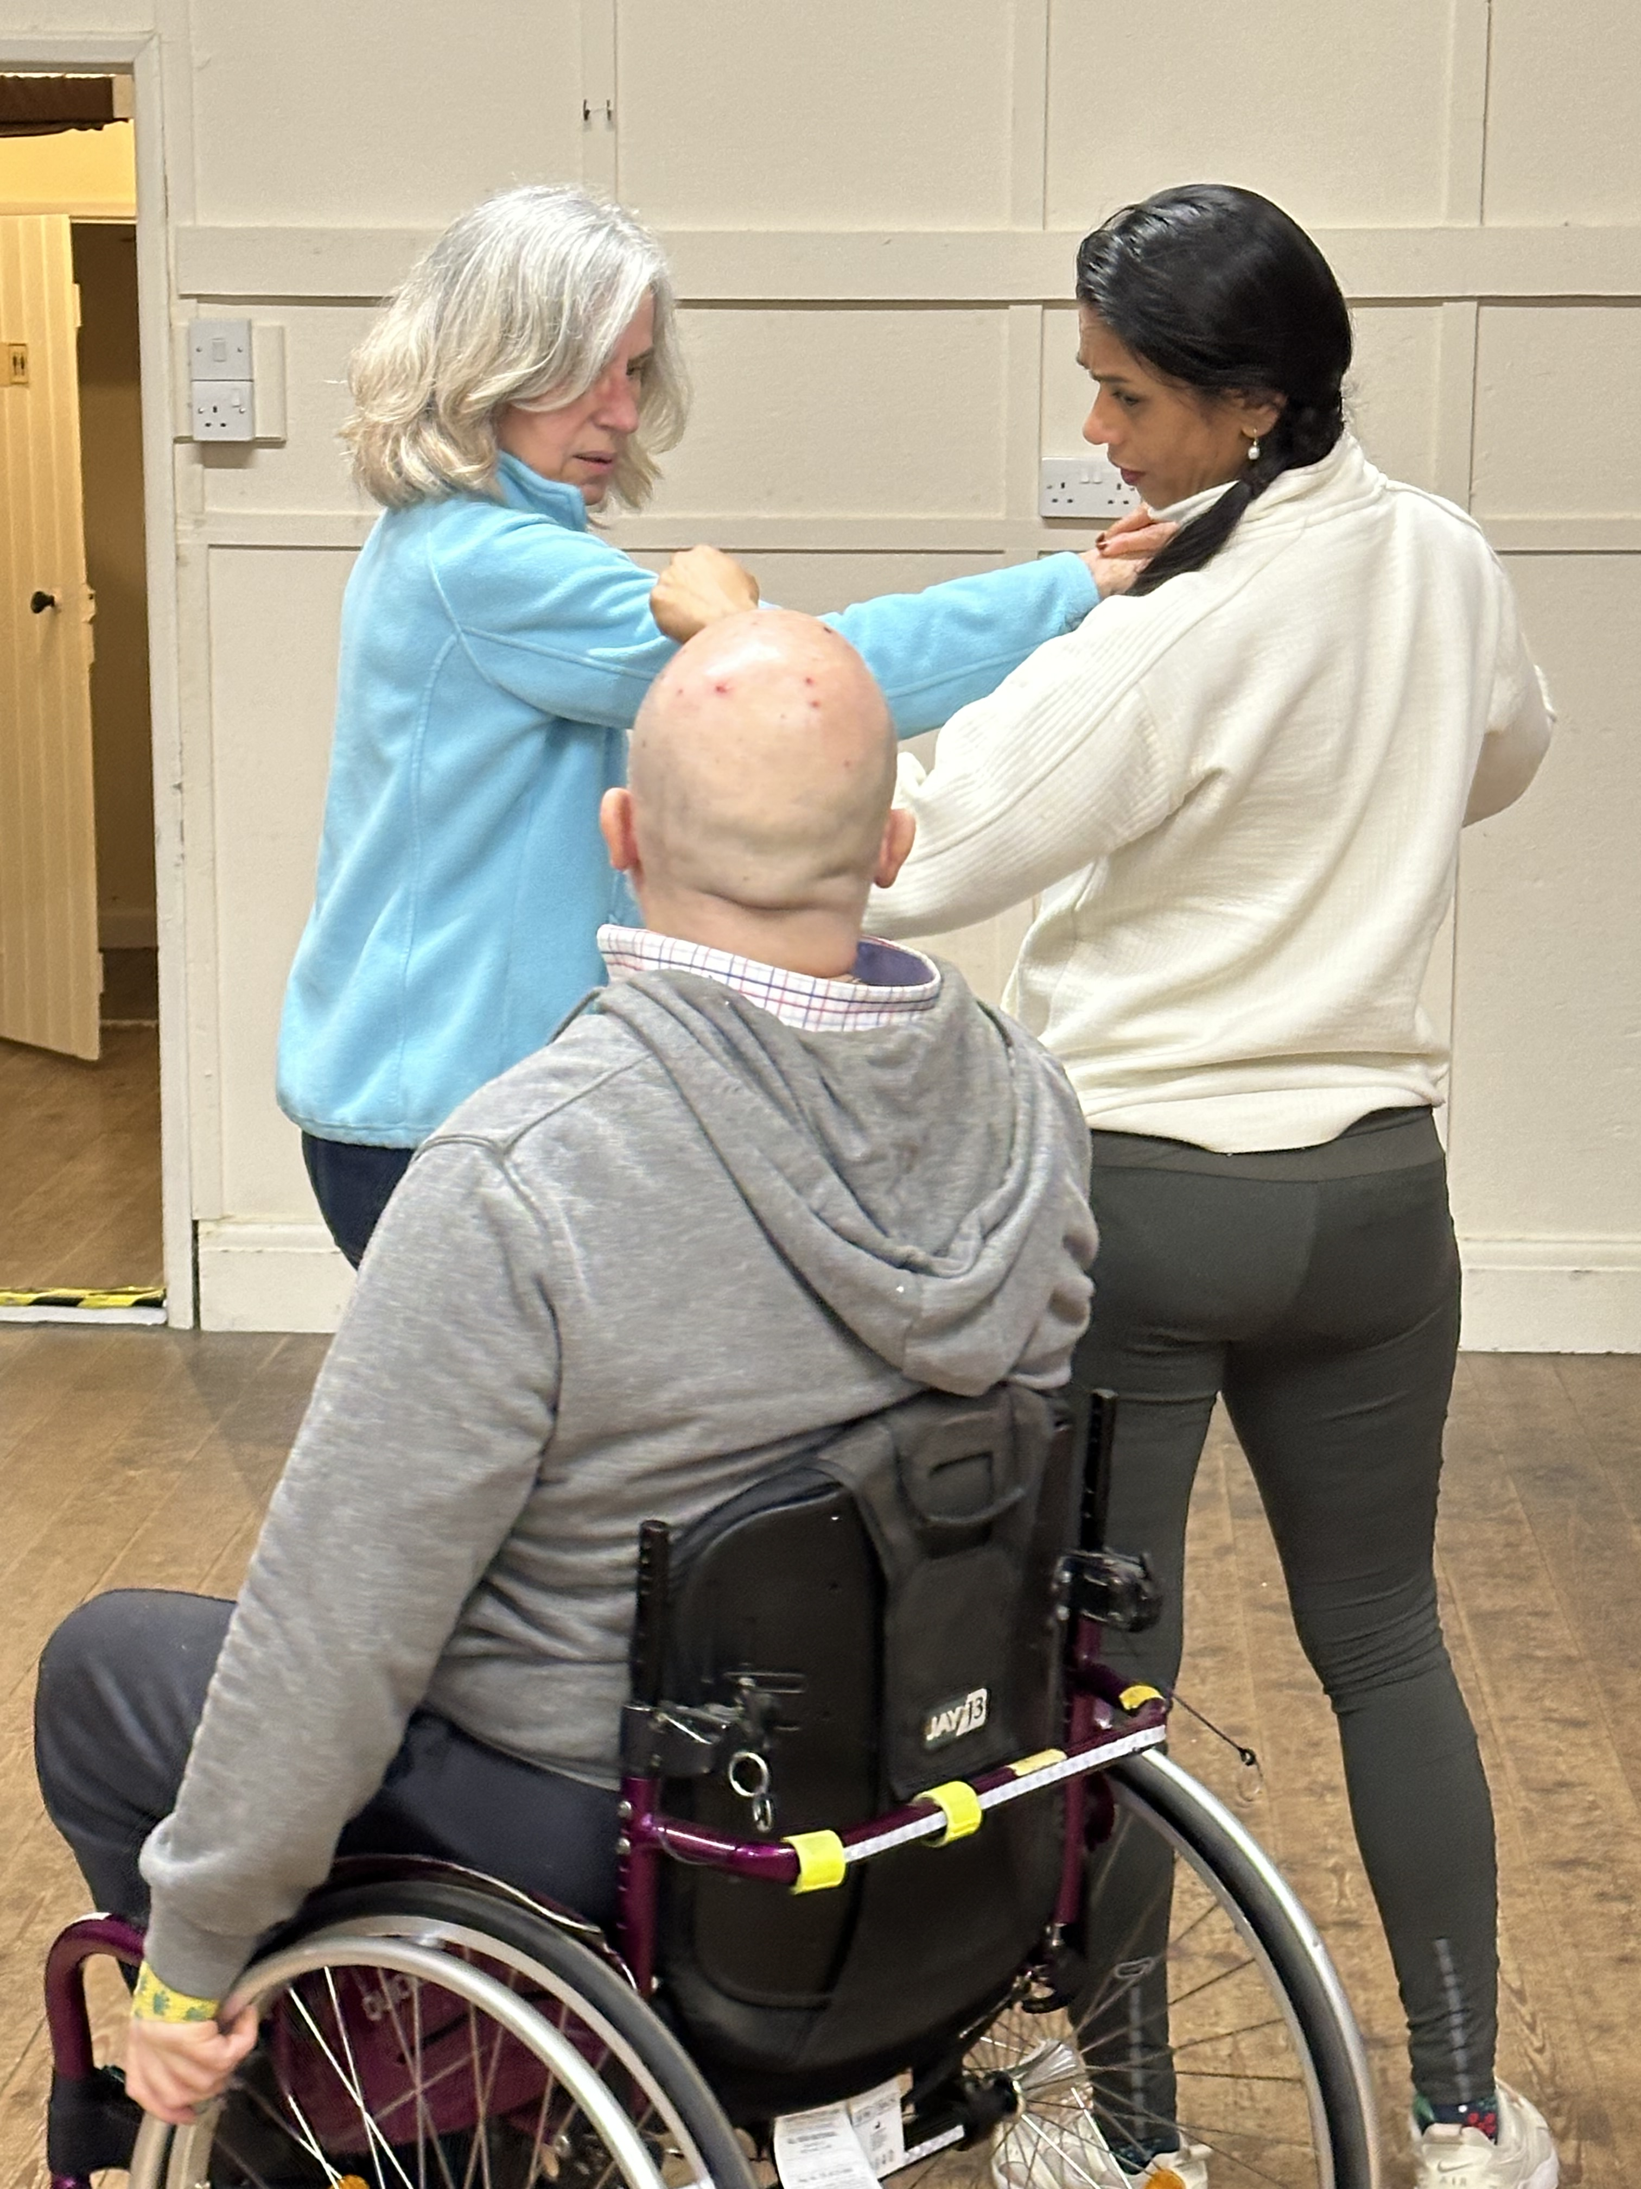

 March 2026 Meeting

Self Defense Night
Thanks very much to Glen, who led us through some basic self-defense actions tonight. We spent time practicing some evasive moves and considering how to protect ourselves from harm. Glen helped us think critically about how to use our body mass, how to make the best use of our weight when we feel under attack. Glen’s parting advice was very clear – the best form of keeping ourselves safe is to be very aware of our surroundings. We urge everyone to be aware of any unusual behaviour, think carefully about entering potentially unsafe spaces and be mindful of erratic behaviours. It was a timely reminder to not be distracted by our phones when in public space – but use our senses to be vigilant of our surroundings. Glen has a weekly self-defense class in the WI hall is anyone would like to join – see Polly for details.  Notices
  13th March | Parisian Cabaret and Supper at Chevington WI
  21st March  2pm | Walking Tour of Clare - £3 per person – If you've signed up for this. – please meet us in the Old Goods Shed care park at 1:45. Cash payment on the day.
  